

**ISTANBUL AYDIN UNIVERSITY**

**COMPUTER PROGRAMMING II**

**PROJECT REPORT**

**PROJECT NAME: AIRLINE MANAGER SYSTEM**

**Talha Özel B1705.090016 Software Engineering**

**TABLE OF CONTENTS**

1. **INTRODUCTION**
   1. PROJECT AIMS AND OBJECTIVES
   2. BACKGROUND OF PROJECT
   3. OPERATION ENVIRONMENT
   4. UML CLASS DIAGRAM
2. **CODES**

SCREENSHOTS

**INTRODUCTION**

This chapter gives an overview about the aim, objectives, background and operation environment of the system.

**1.1 PROJECT AIMS AND OBJECTIVES**

The aims and objectives are as follows:

* All family members can save their families.
* The family can save their heritage tree for years.
* Family members can see their family members age, name etc.

**1.2 BACKGROUND OF PROJECT**

This program allows families to save their heritage to subsequent family members.

You can add new family members in ‘’add’’ menu. There is also one which deletes members also update menu to change wrong infos about the person.

**1.3 SYSTEM REQUIREMENTS**

|  |  |
| --- | --- |
| MEMORY | 1GB RAM OR MORE |
| HARD DISK SPACE | MINIMUM 5 GB FOR DATABASE USAGE FOR FUTURE |

**UML CLASS DIAGRAM**

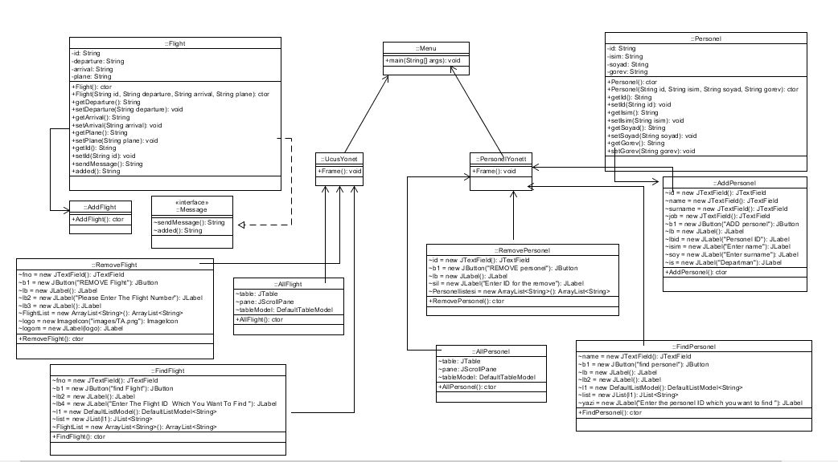

**MENU CLASS CODES**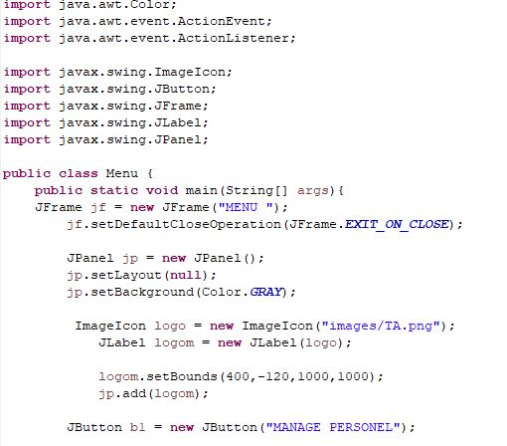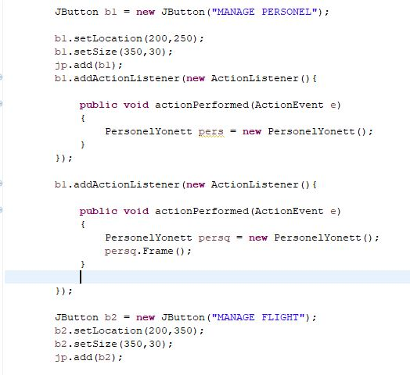

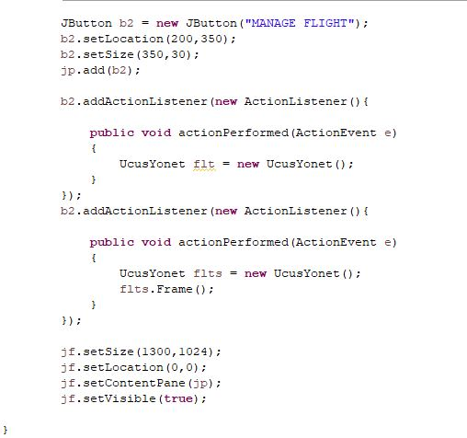

**UCUS YONET CLASS CODES**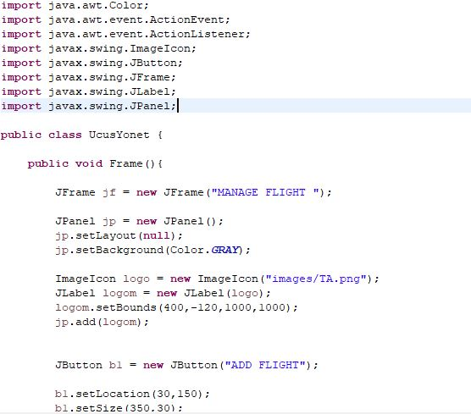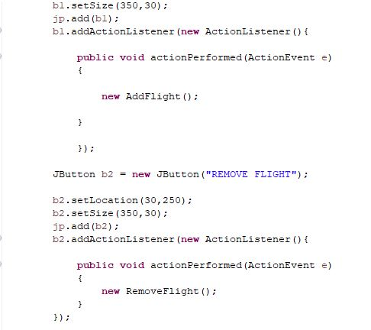

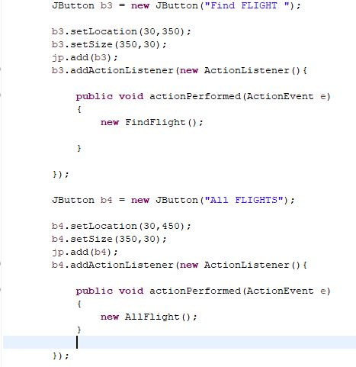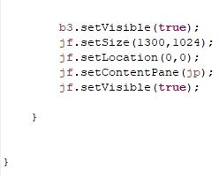

**PERSONEL CLASS CODES**

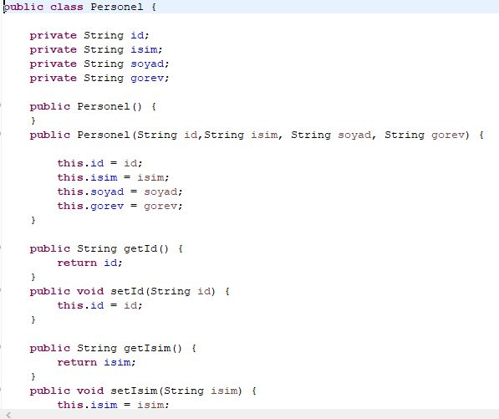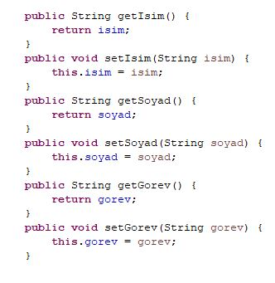

**FLIGHT CLASS CODES**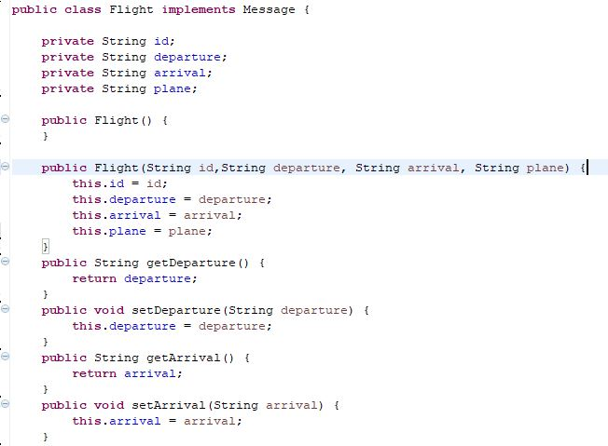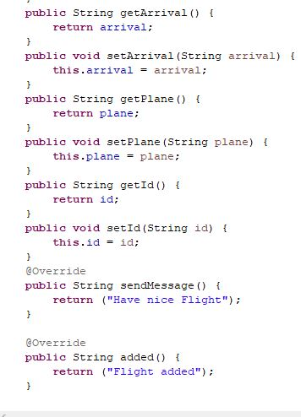

**MESSAGE CLASS CODES**

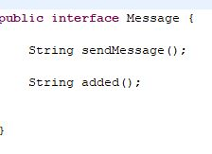

**PERSONELYONET CLASS CODES**

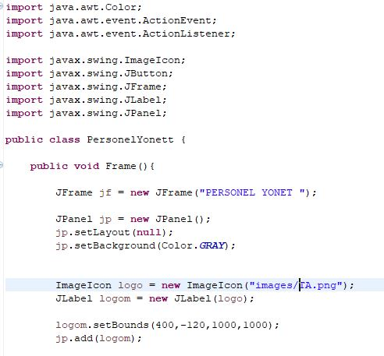

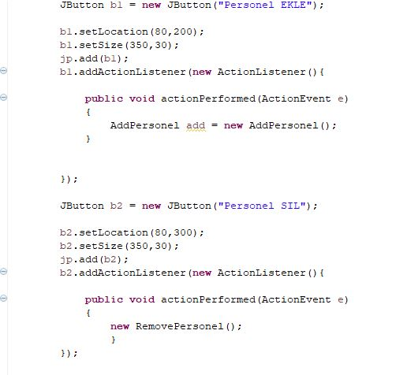

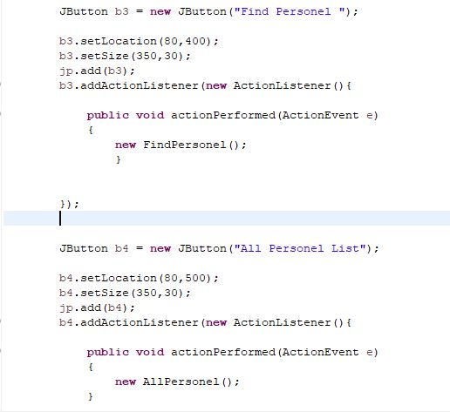

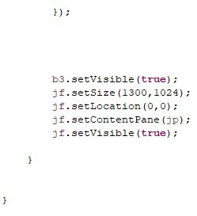

**ADDFLIGHT CLASS CODES**

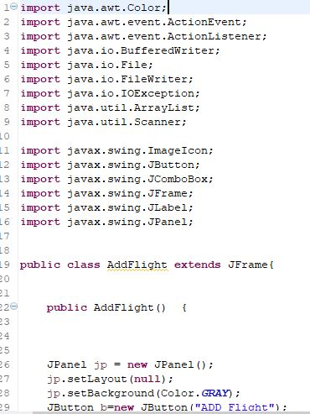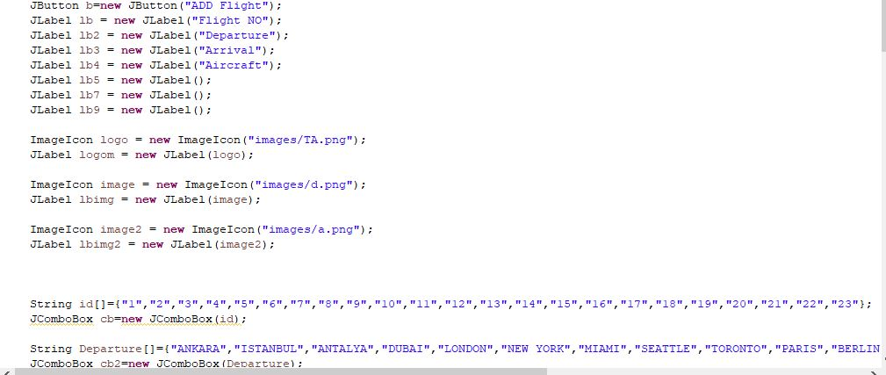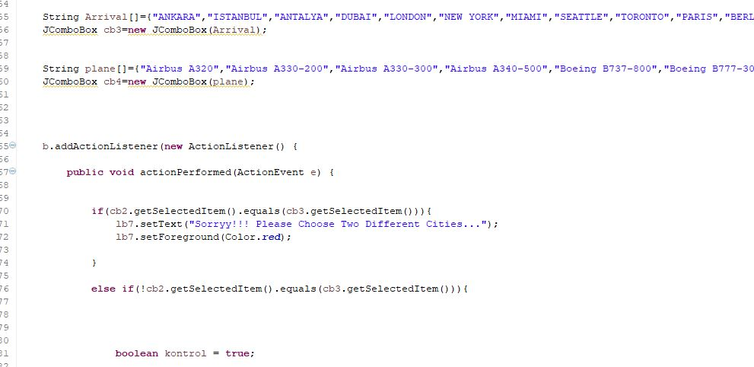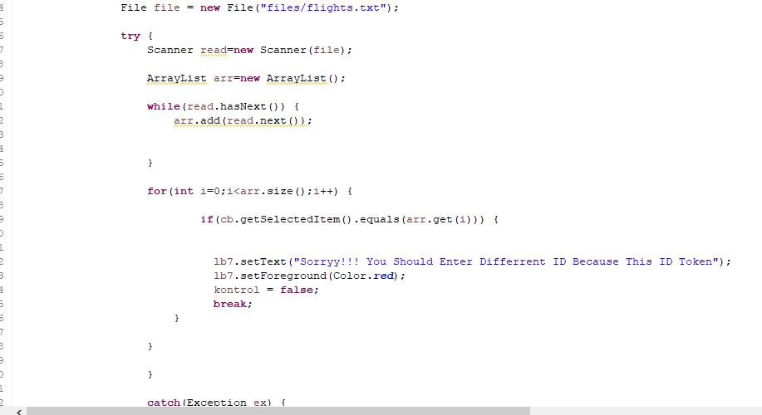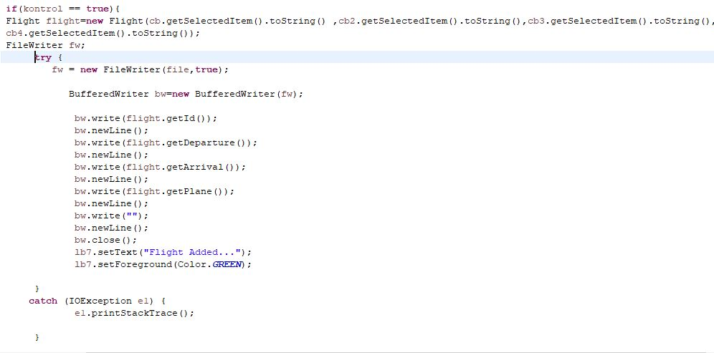

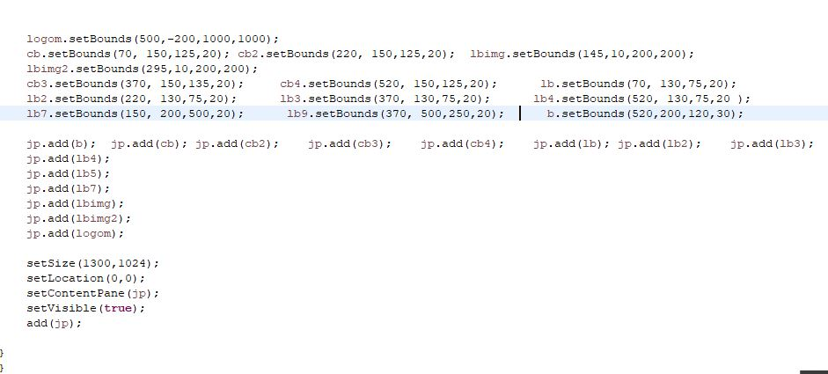

**ALLFLIGHT CLASS CODES**

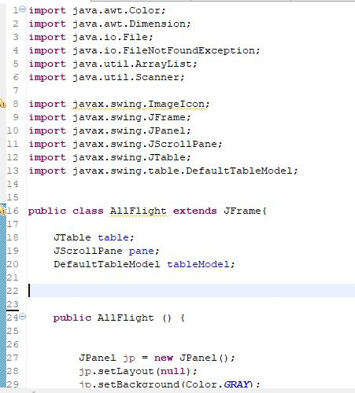

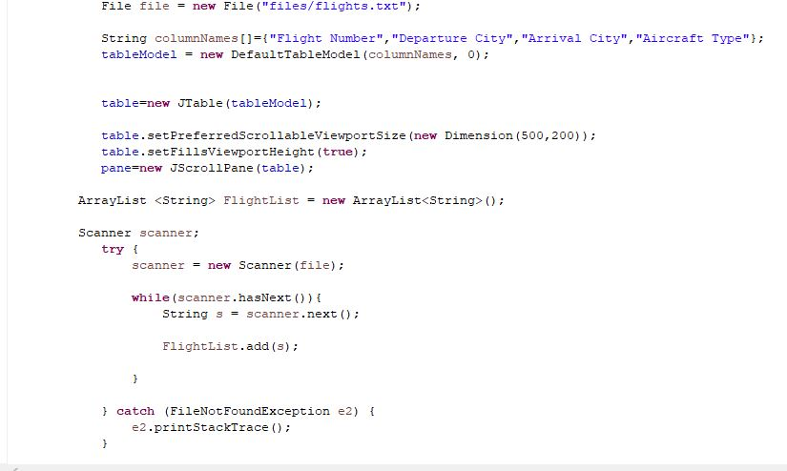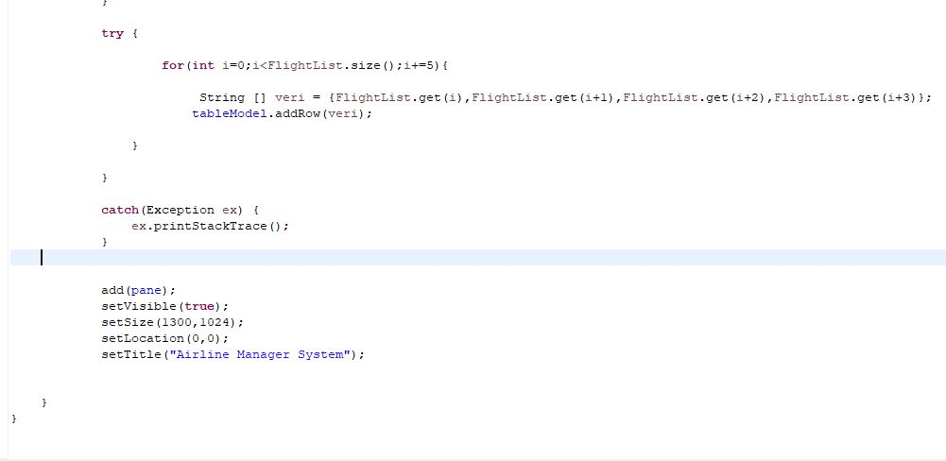

**ALLPERSON CLASS CODES**

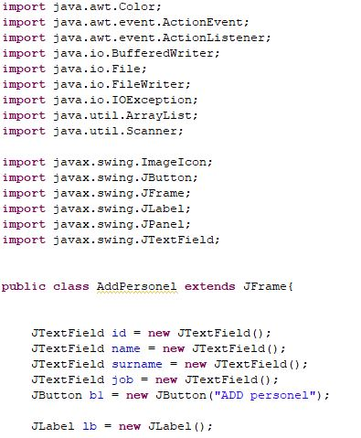

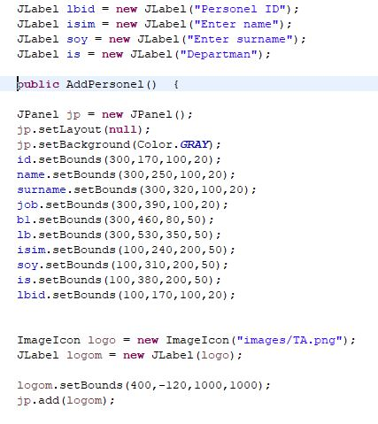

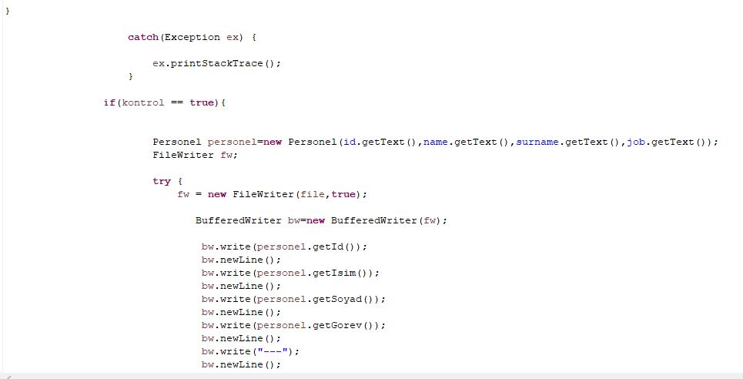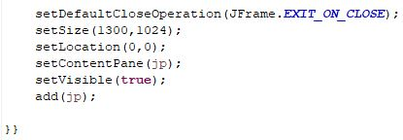

**FINDFLIGHT CLASS CODES**

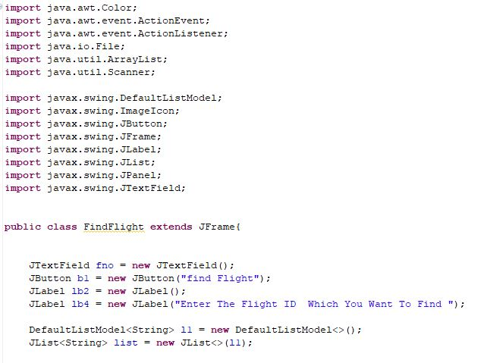

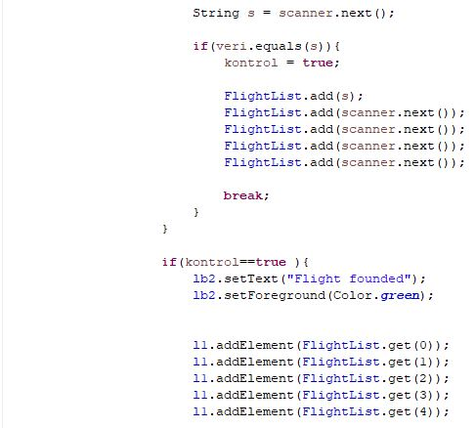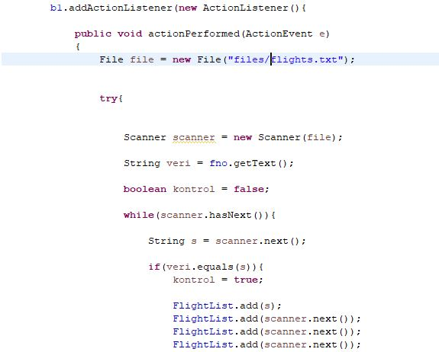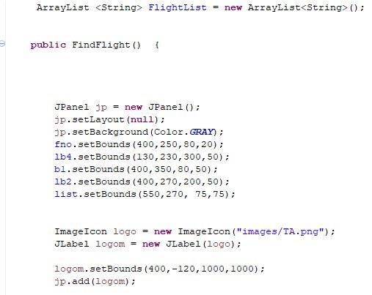

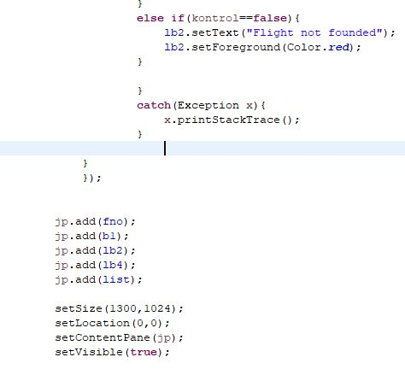

**FIND PEROSNEL CLASS CODES**

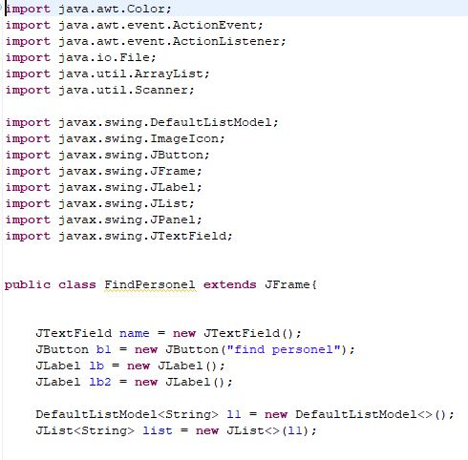

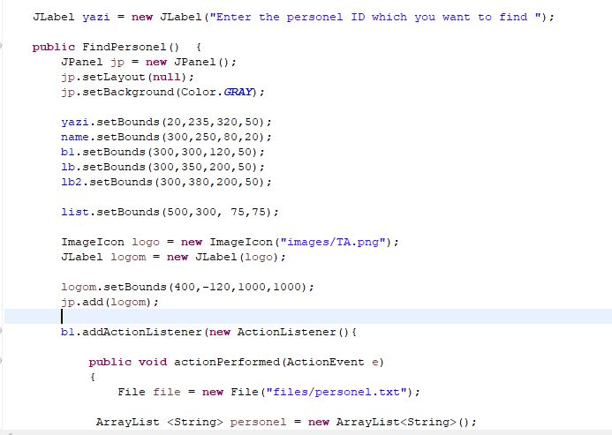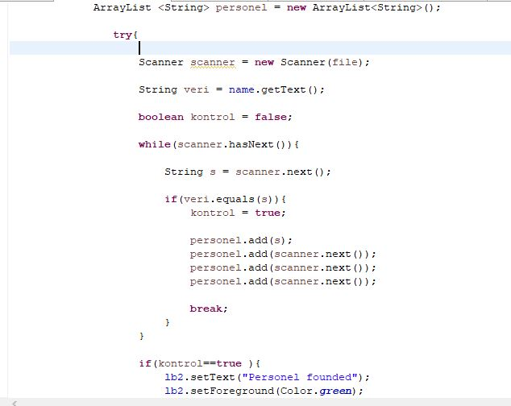

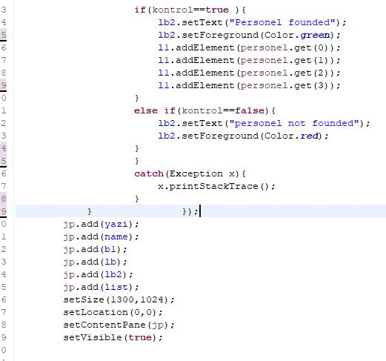

**REMOVE FLIGHT CLASS CODES**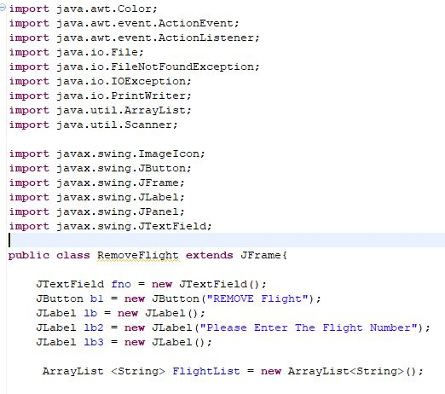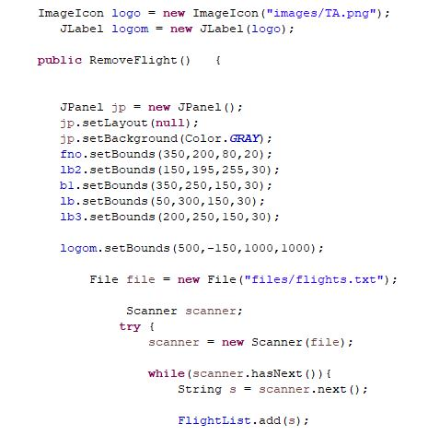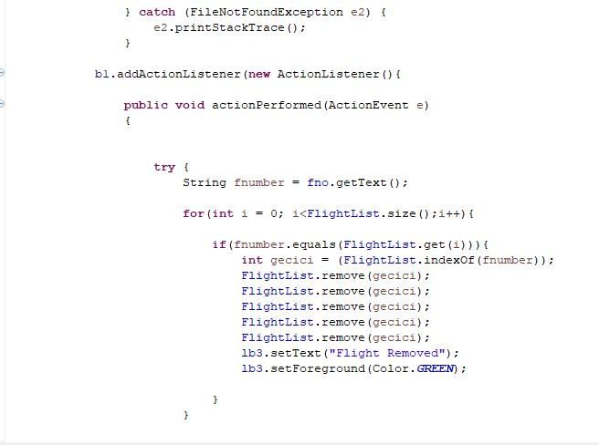

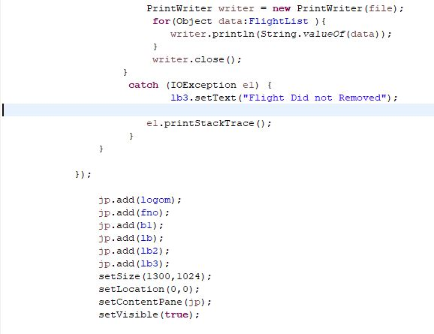

**REMOVE PERSONEL CLASS CODES**

